Nama : Firly Nurlya R
NIM : 4510210032
Praktikum sesi 4 - Pemrograman 4
Index.jsp
<html lang="id">
<head>
<title>Form</title>
</head>
<body>
<h1>Entri Data</h1><hr>
<form action="output.php">
<table border="0">
<tr><td>Kode</td><td><input type="text" name="kode"></td></tr>
<tr><td>Nama</td><td><input type="text" name="nama"></td></tr>
<tr><td>Harga</td><td><input type="number" name="harga"></td></tr>
<tr><td>Terakhir Update</td><td><input type="date" name="terakhirUpdate"></td></tr>
<tr><td><input type="submit" value="Simpan"></td></tr>
</table>
</form>
<footer>
&copy Firly Nurlya Rahim - 4510210032
</footer>
</body>
</html>

Printscreen

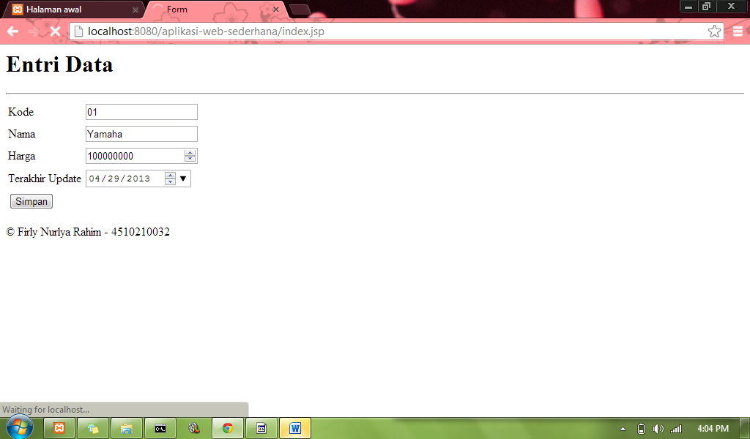
Hasil
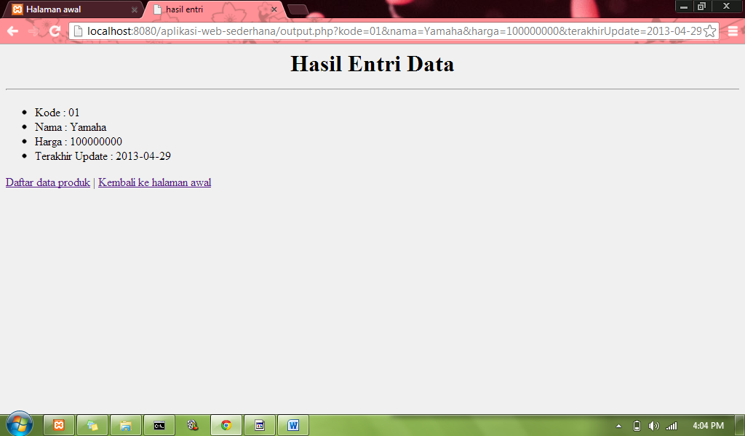

Daftar data produk
OutputDao.php
<%@ page import="java.io.*,java.util.*,java.sql.*"%>
<%@ taglib uri="http://java.sun.com/jsp/jstl/core" prefix="c"%>
<%@ taglib uri="http://java.sun.com/jsp/jstl/sql" prefix="sql"%>

<html>
<head>
<title>Daftar Data Produk</title>
</head>
<body bgcolor=#f0f0f0>

<sql:setDataSource var="snapshot" driver="com.mysql.jdbc.Driver"
url="jdbc:mysql://localhost/p4"
user="root" password=""/>

<sql:query dataSource="${snapshot}" var="result">
SELECT * from produk;
</sql:query>
<h1 align="center">Daftar Data Produk</h1><hr><p>
<table border="1" width="430" height="70" align="center">
<tr>
<th>Kode</th>
<th>Nama</th>
<th>Harga</th>
<th>Terakhir Update</th>
</tr>
<c:forEach var="row" items="${result.rows}">
<tr>
<td><c:out value="${row.kode}"/></td>
<td><c:out value="${row.nama}"/></td>
<td><c:out value="${row.harga}"/></td>
<td><c:out value="${row.terakhirUpdate}"/></td>
</tr>
</c:forEach>
</table>
<p align="center"><a href="index.jsp">>> Kembali ke halaman awal</a>
</body>
</html>

Printscreen
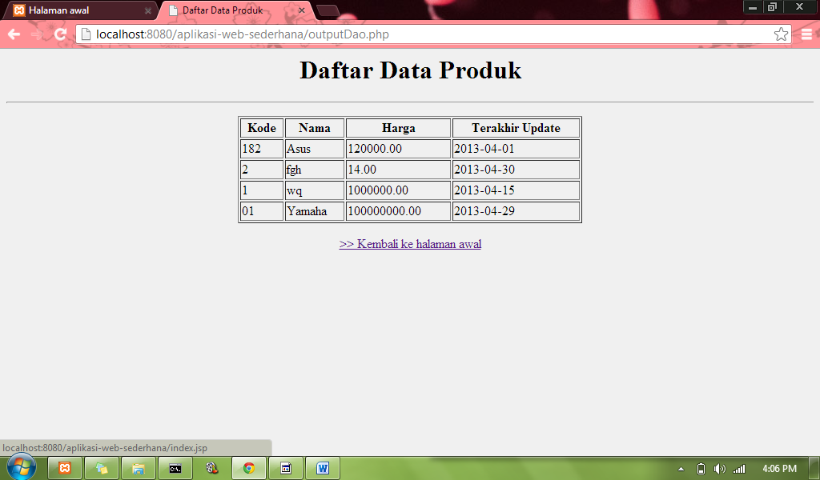
Kembali ke halaman awal untuk ke input.jsp

